

MAY 2021
ISSUE FIVE
WCBA NEWS

100th Celebration Service
May 23, 2021 5:00 – 6:30
First, Lebanon

Congregational Singing and Special Music . . . Mark Caruth

Welcome and Prayer . . . David Freeman

Highlight Video of Churches

Special Music . . . Mark Caruth

Recognition of Descendants and Guests . . . Dave Shelley

Presentation of TBMB . . . Randy Davis

Singing and Specials . . . Mark Caruth

Message . . . Roc Collins

Invitation . . . Pastors

Benediction . . . Dave Shelley

Masks are Optional.

Service will be streamlined on First Baptist Lebanon Facebook.

Book of Histories from our Associational Churches

Gospel Conversation Training at 1st Lebanon
Thursday, May 20th 9:00 a.m. – 3:00 p.m.
Led by Ross Ramsey, 1st Baptist Allen, TX

Ross Ramsey and his church (First Baptist Church Allen, Texas) went from having relatively little evangelistic activity to in the past few years training hundreds of church members (plus hundreds more from other churches) and having dozens from the church teaming up twice a week to evangelize their city with over 25,000 gospel conversations and counting!

The training is for pastors, staff, and lay leaders. It will include lunch and afternoon practice on teams with experienced modelers. Register by contacting 1st Lebanon 444-3330. Any questions contact Benji Thomas at the church.

Dave’s Lines . . . Well Done!

A word of THANKS to the following:

Fall Creek Baptist Church for hosting our Associational Bible drill and Edna Richardson for serving as our Associational director. Thank you to Fall Creek. First, Watertown and Round Lick to the drillers and leaders for putting all the hard work into Bible drill. Thank you to the parents for working with their children and youth.

The following children and youth participated in the Associational drill:

Daniel Harris, Round Lick, 4th grade, 1st year; Benjamin Crook, Round Lick, 6th grade, 3rd year; Autumn Crook, Round Lick, 4th grade, 2nd year; Jenna Pruitt, Watertown First, 4th grade, 1st year; Macy Malone, Watertown First, 4th grade, 1st year; Emma Williams, Fall Creek Baptist, 4th grade, 1st year; Benjamin Granstaff, Fall Creek, 4th grade, 1st year; Isabella Underhill, Fall Creek, 5th grade, 2nd year.

High School:

Summer Crook, Round Lick Baptist, 2nd year

Youth:

Alyssa Crook, Round Lick, 2nd year

Hillcrest Baptist Church for hosting our Associational VBS Training. We are blessed to have Rachel Presley serve as our VBS director. She is the BEST there is in the state and our team is awesome. The following served on our Associational VBS training team: Ruthie Henslee (Preschool); Brandy Holcomb (children); Brandon Patton (youth); Amanda Bennett (Crafts); Kristy Elmore (Music); Sue Denney (Special Friends); and Todd Capps (General Directors).

And finally . . .

Mt. Olivet Baptist Church and Rodney Duckett for hosting a luncheon for our pastors. This was a very good thing and very much needed and all who ate and fellowshipped seemed very appreciative!

THANK YOU all for a Job Well Done!!!

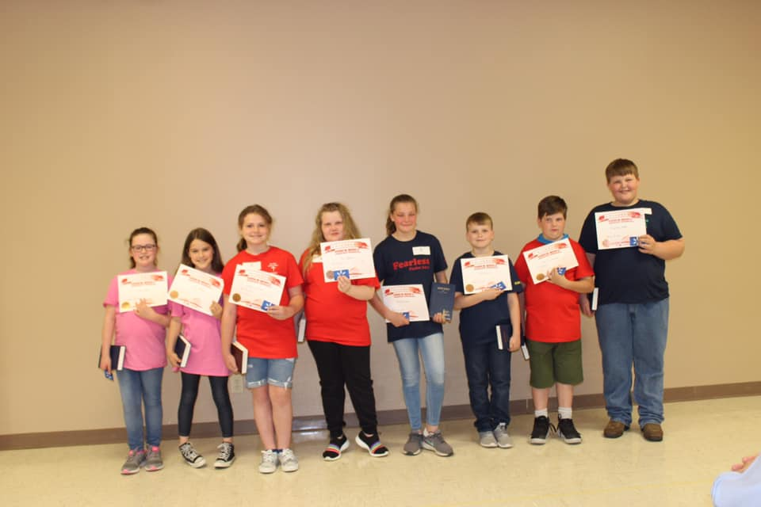
REAL
REVIVAL
CONFERENCE
BRINGING US BACK TO THE BIBLE

WHEN WHERE
May 2-8, 2021 Cedar Grove Baptist Church
6:30 each night 2485 Cedar Grove Rd., Lebanon

(Childcare Provided)

WWW.CGBCLEBANONTN.ORG



First Baptist Lebanon
200th Celebration

Bicentennial Worship Service and Homecoming –
Sunday,
June 27th at 10:30 a.m.

“Light-Up Lebanon”
Community Birthday Party – Wednesday,
June 30th at 6:00 p.m.

ISSUE FIVE
MAY 2021

Special Needs Picnic

Saturday, May 15 11:00 – 2:00

West Haven Baptist Church

The ballgame continues…plus corn hole tournament plus burgers.

Special Needs VBS and Bowling

Saturday, July 12

We are still working on the details

Barton’s Creek:
July 11-15 6-8:30 pm

Cedar Creek:
July 12-16 6-8:45 pm

Cedar Grove:
June 14-18 9:00 am – 12:30 pm
“Destination Dig”

Community:
June 7-11 6-8:30 pm

Grace:
June 21-24 5:45 – 8:30 pm

Hillcrest:
June 7-11 9:00 am – 12:30 pm

Immanuel:
July 12-16 8:30 am – 12:00 pm

1st Mt. Juliet: June 21-23
Backyard Kids Clubs

Mt. Olivet:
June 16-19 6-9:00 pm

Round Lick:
June 13-17 6-9:00 pm

Shop Springs:
July 19-23 9:00 am – 12:00 pm

Silver Springs:
June 7-11 9:00 am
3 years – 5th grade

Victory:
June 14-17 Preschool VBS
9:30 am – 12:00 pm
For (currently 3 yrs to 5 yrs old)
Must be the age of 3
by January of 2021.

June 21-25 VBS
8:30 am– 12:00 pm
For (recently completed kindergarten to 5th grade)

West Haven: July 26-28
6:30-8:30 pm
“Destination Dig”


Summer Day Camps

Simply the Best
9:00 – 2:00
Cost: $20 for all 4 days

The best Opening, Individual, Team, and Water games of 50 years of day camps with Dave Shelley plus Favorite Bible stories and Living stories.

Promotional flyers are available at the office for ALL day camps.

May 25-28 New Middleton
Baptist Church
June 21-24 Hillcrest Baptist
Church
June 21-24 Cedar Creek Baptist
Church
5:30-8:00 Cost $15
for week
July 5-8 Watertown Ball Park
July 12-15 Victory Baptist Church
July 19-22 West Main, Alexandria


Children’s Camp at Carson Springs
July 26-30 Cost: $200
Theme: The Great Shepherd Psalms 23

Jesse McKay, camp director
Brandon Patton, camp pastor
Jacob Lannom, camp worship leader
Bradly Vickers, recreation leader

We got the campground to ourselves and are gearing up a great week of non-stop activity from Bible study to worship to wild and wacky games to swimming. It is our kids and leaders intermingling together for a week away before the start of school. What a GREAT way to end the summer!

Registration and camp details are available at the Associational office.


Encounter Camp 2021
Cumberland University
June 28-July 2
Cost: $150

Camp to include Bible Study, Worship, Rec, Mission Sites, Church Group Time, and Night Life.

Contact: Darrin Reynolds or Brenna Luttrell

Darrin.reynolds@immanuelbaptist.com or Brenna.Luttrell@immanuelbaptist.com

MAY 2021

Wilson County Baptist Association
P.O. Box 2190
Lebanon, TN 37088
615-444-8820
www.wcbamissions.com

The 2020/2021 school has come to a close. In the midst of this year God has blessed our ministry at Cumberland. Our leadership team of students have been faithful and intentional in their ministry. We have experienced a lot of spiritual growth and faith breakthroughs. Thank you for your prayers and support! We are looking forward to the 2021/2022 school year and getting many of you back on campus for ministry!!

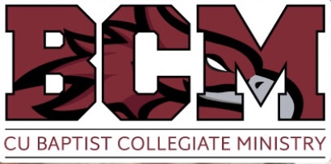
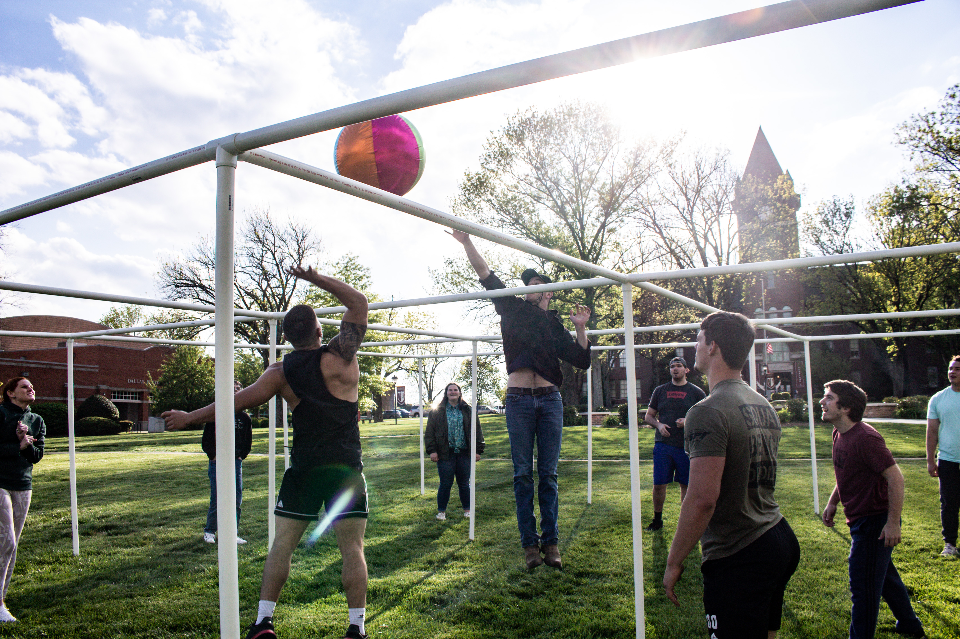
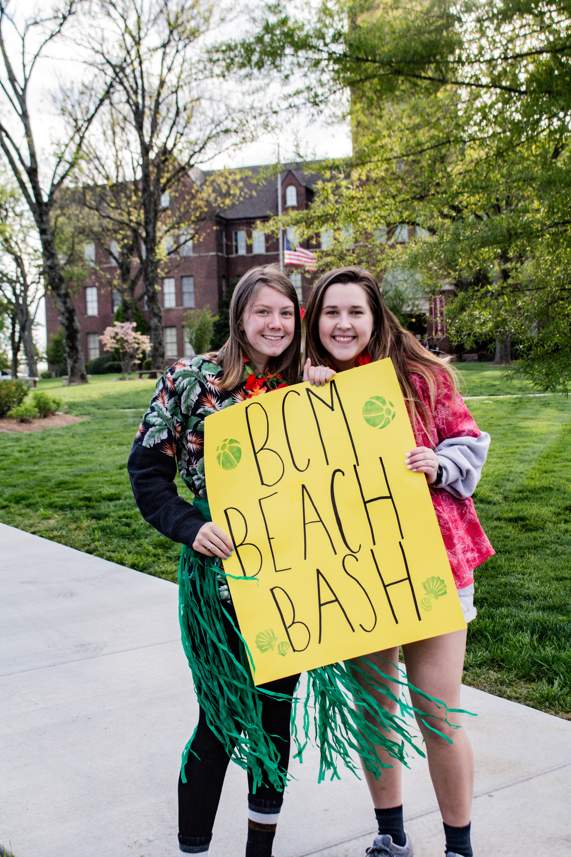

WMU Spring Retreat

If you signed up

for the
Catered Breakfast,
don’t forget to attend on
May 1st at 9:00
Hope Baptist Church

Carson Springs Conference Center
Ministers Getaways

Off Grid Project (Fly Fishing) May 2-5

Off Grid Project (Backpacking) August 22-25

Off Grid Project (Backpacking) October 17-20)

To register call 1-423-623-2764.

Part-time Church Secretary Position
Seeking candidate to work two eight-hour days as a part-time church secretary on Monday and Tuesday of each week. This person will type correspondence; receive, sort, and route mail; answer the phone and route messages; greet visitors; fill in for full-time secretary as needed and any other duty as assigned by the pastor. If interested, contact Will Turner at 615-758-7853 or 731-589-3545.

